NAME: GUGGILLA ANUJA
ROLLNO: 2403A51101
BATCH NO: 05
Task 1 –
Analyze an AI-generated Python login script for input validation vulnerabilities.
Instructions:
- Prompt AI to generate a simple username-password login program.
- Review whether input sanitization and validation are implemented.
- Suggest secure improvements (e.g., using re for input validation). Expected Output:
- A secure version of the login script with proper input validation.
PROMPT:
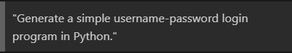

CODE:
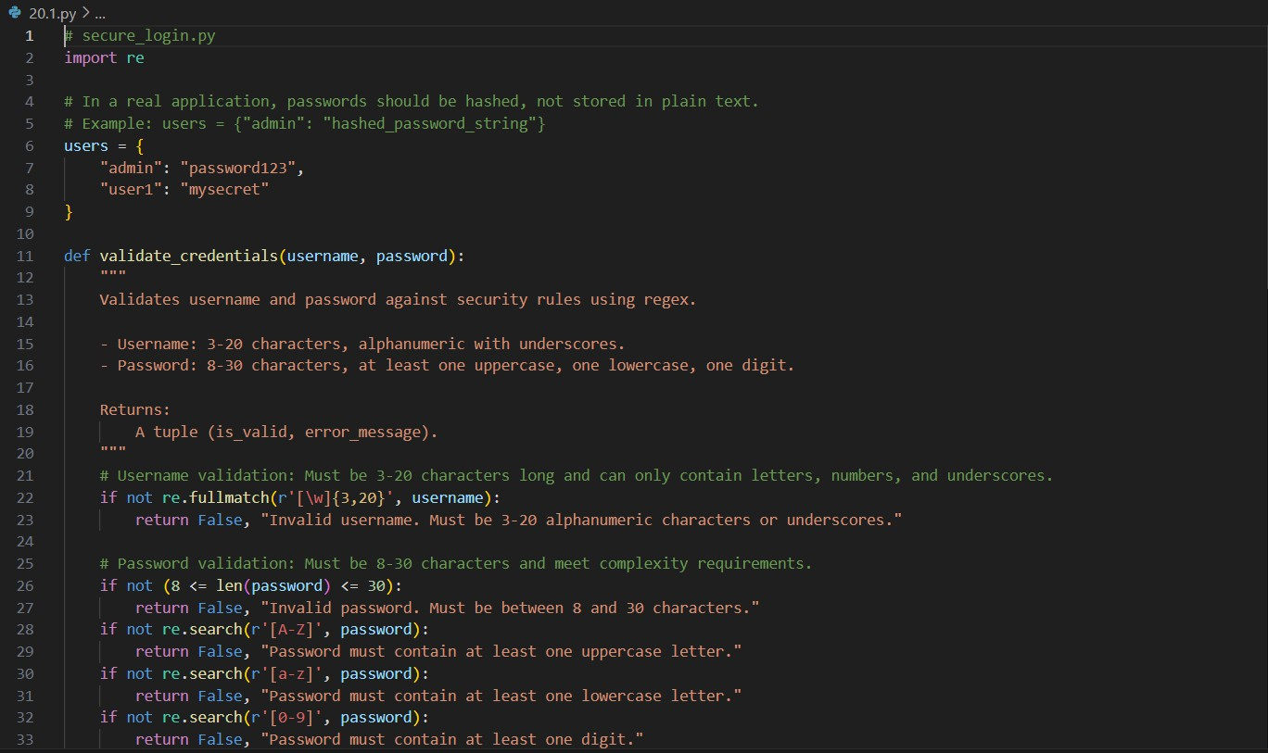

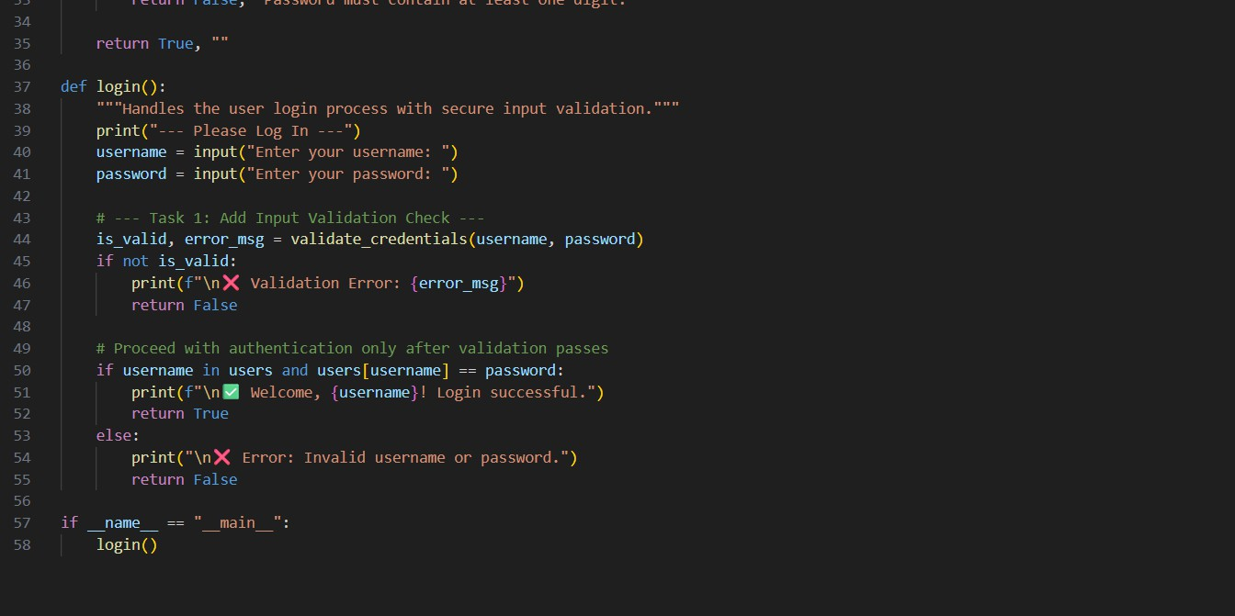
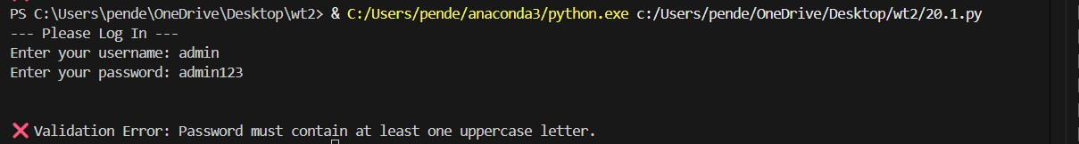
OUTPUT:

OBSERVATION:

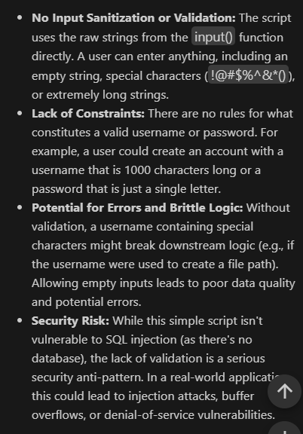
TASK-2 PROMPT:
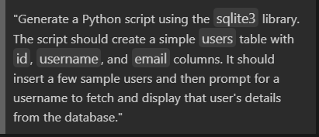
CODE:

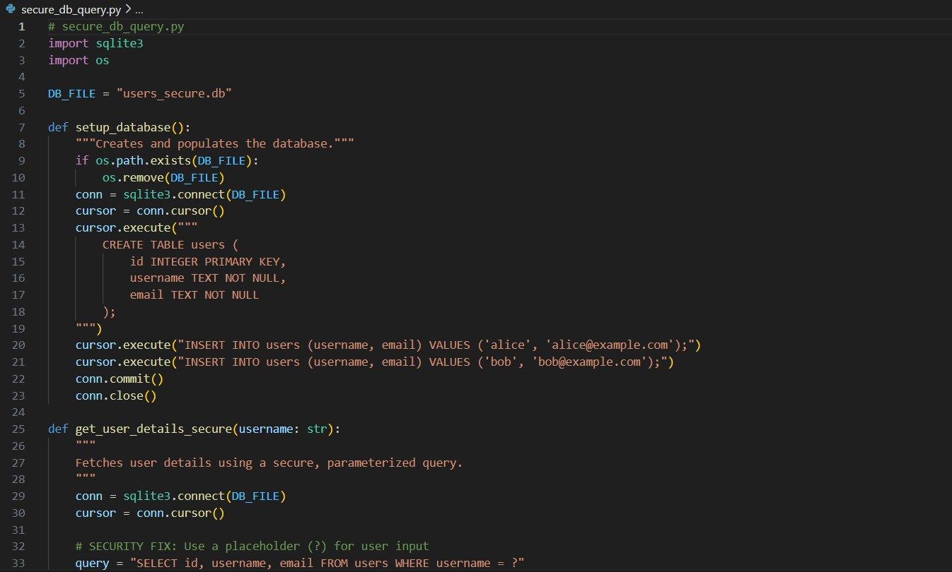

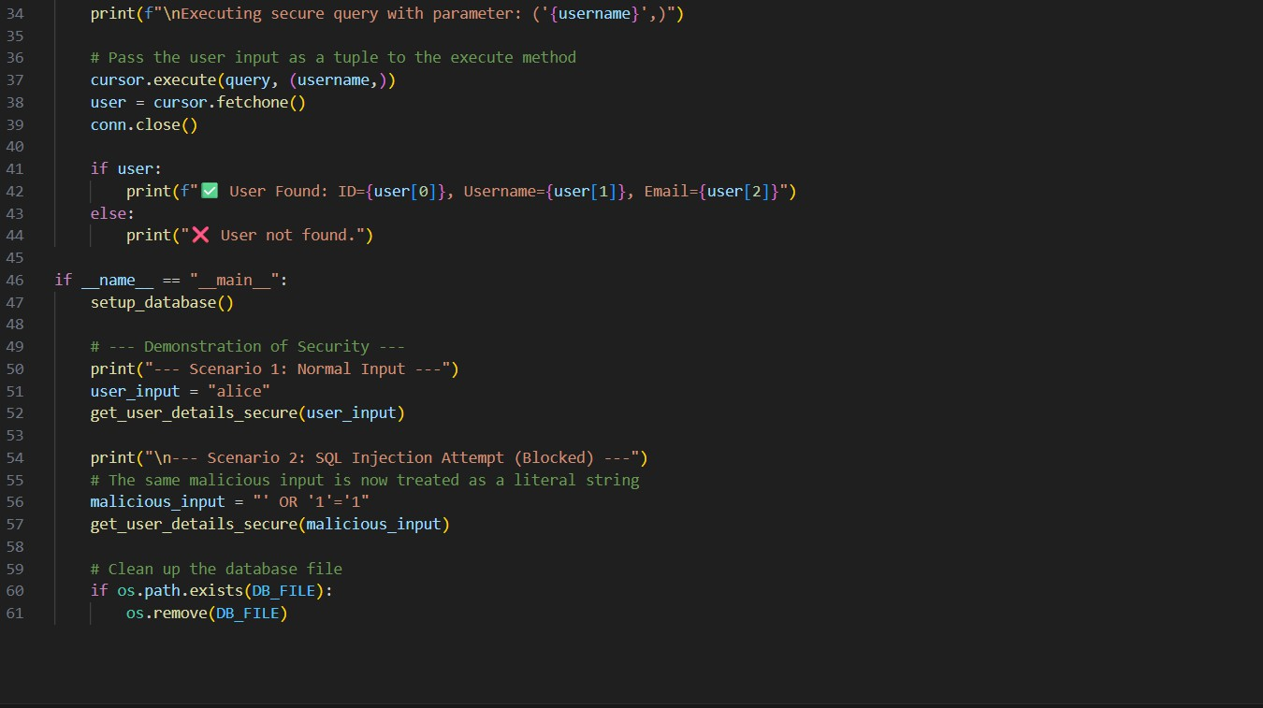
OUTPUT:
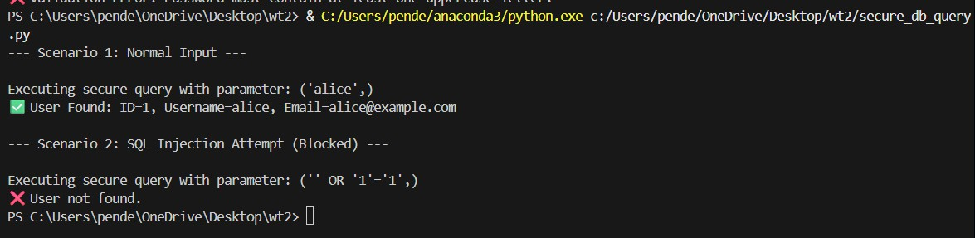

OBSERVATION:
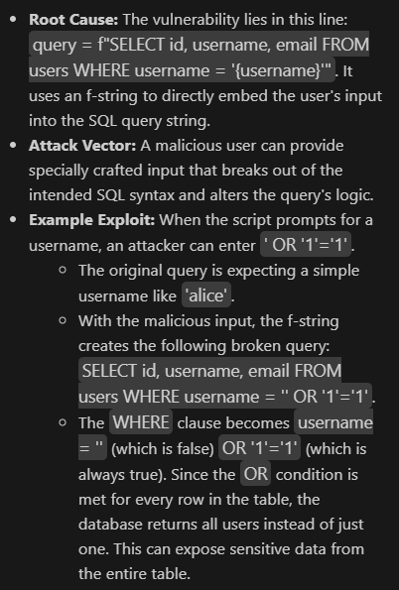
TASK-3: PROMPT:
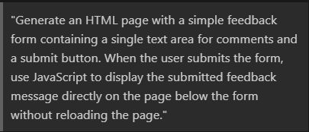
CODE:

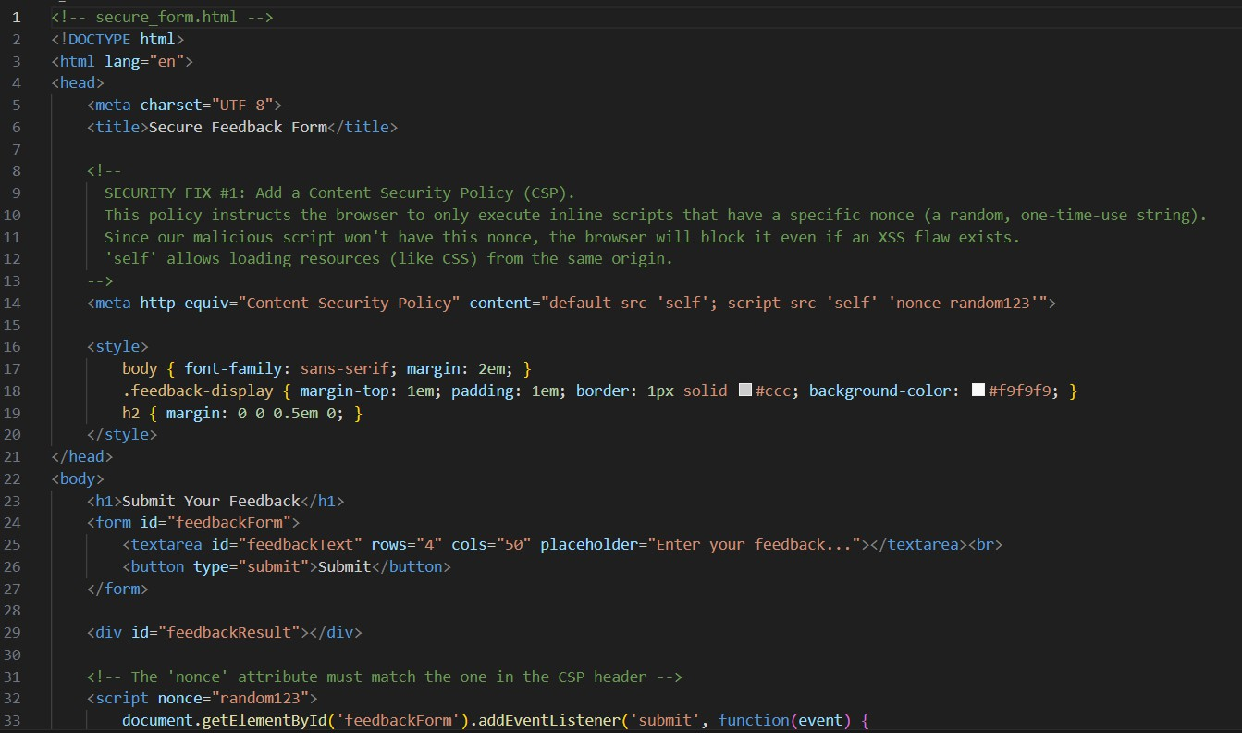
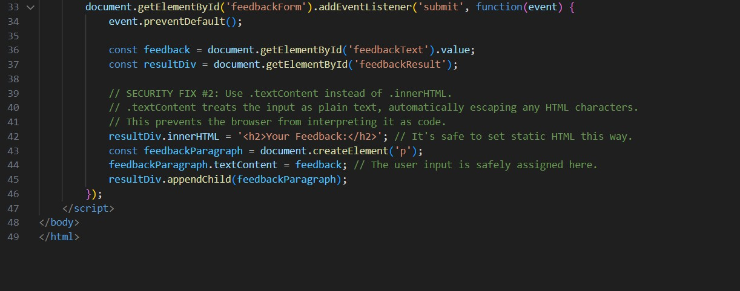
OUTPUT:

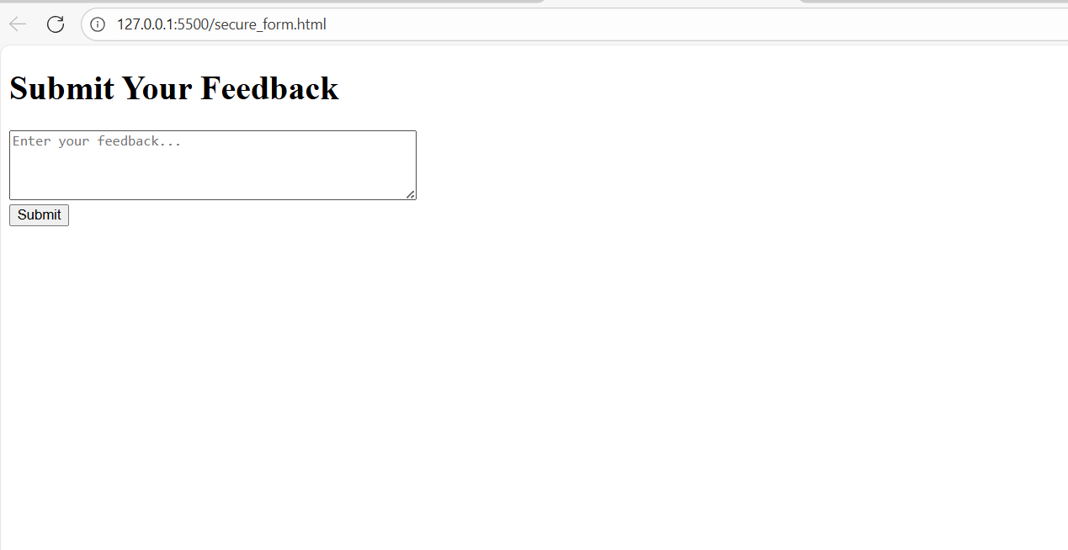
OBSERVATION:
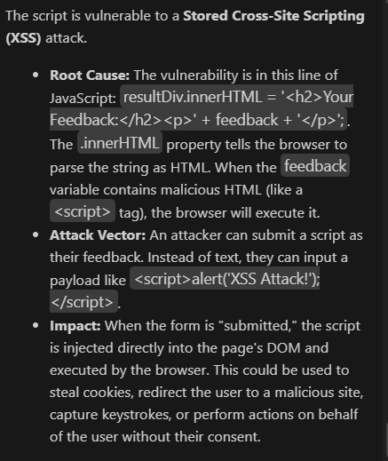
TASK-4:

Scenario:
Students pick an AI-generated project snippet (e.g., login form, API integration, or file upload).
Instructions:
- Perform a security audit to detect possible vulnerabilities.
- Prompt AI to suggest secure coding practices to fix issues.
- Compare insecure vs secure versions side by side. Expected Output:
- A security-audited code snippet with documented vulnerabilities and fixes.
Deliverables (For All Tasks)
- AI-generated prompts for code and test case generation.
- At least 3 assert test cases for each task.
- AI-generated initial code and execution screenshots.
- Analysis of whether code passes all tests.
- Improved final version with inline comments and explanation.
- Compiled report (Word/PDF) with prompts, test cases, assertions, code, and output.
PROMPT:
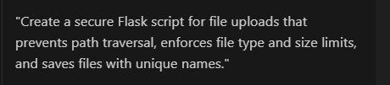

CODE:

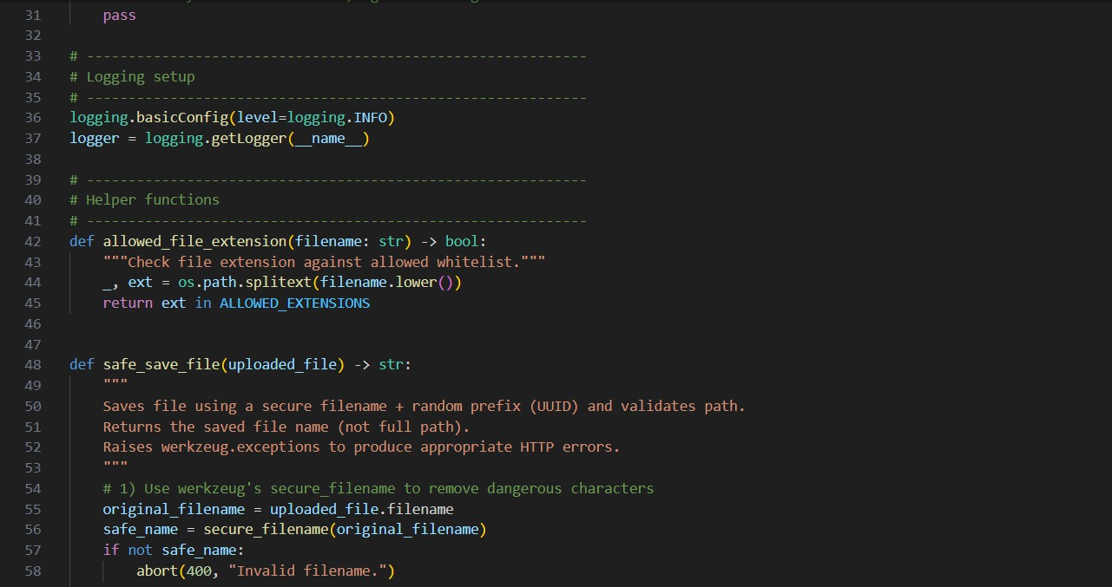
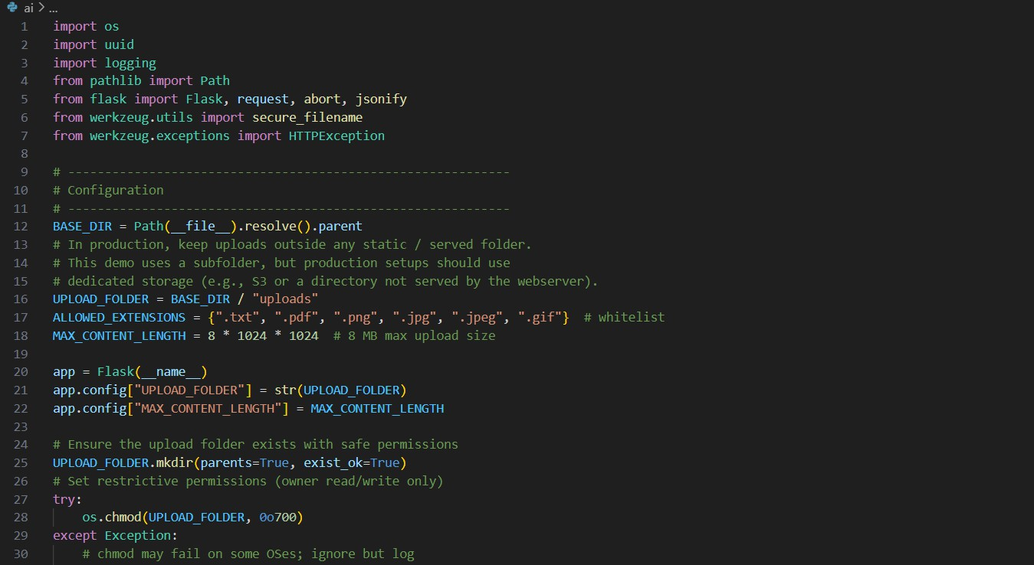

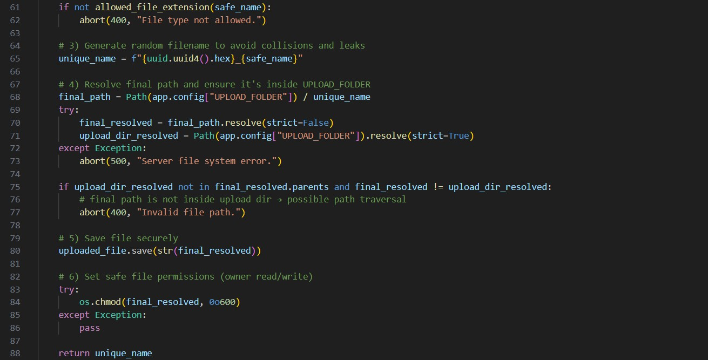
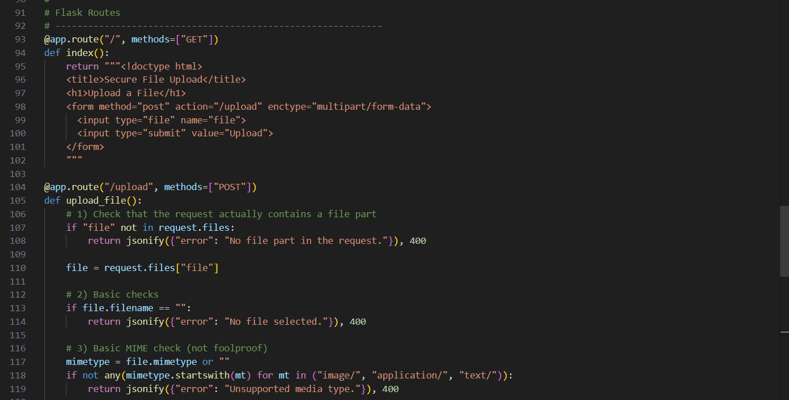
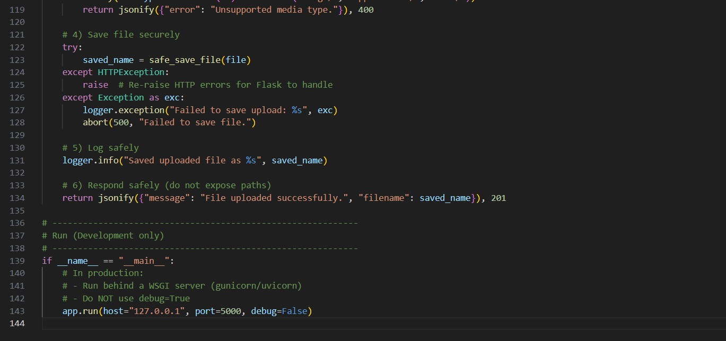

OUTPUT:

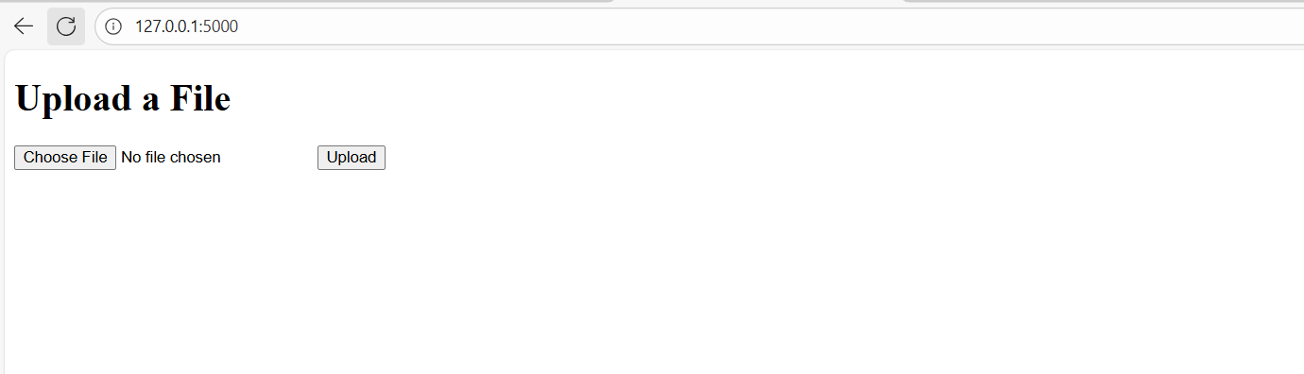
OBSERVATION:
